

| **TITLE**: Introduction to AR.js |
| --- |

**AIM:**

Explore the AR.JS for Web AR

Design the object using any designing tool like blender

Use AR.js to augment it in real world

**______________________________________________________________________**

**Expected OUTCOME of Experiment:**

Student Should Write

**_____________________________________________________________________**

**Books/ Journals/ Websites referred:**

<https://www.youtube.com/watch?v=2ypJ9CFOK5U&list=PLTgRMOcmRb3Nx2LF5EHU4MtmpAQBafVgE&index=1&ab_channel=Packt>

**_____________________________________________________________________**

**Steps to perform:**

**1. Setup Environment: Install a local web server or use a platform like Glitch to host your AR.js project files. Make sure to have a basic understanding of HTML and JavaScript.**

**2. Include AR.js Library: Download or link to the AR.js library in your HTML file. This library will handle the augmented reality capabilities of the project.**

**3. Create an HTML Structure: Set up the HTML file to include a scene for rendering 3D models using the <a-scene> element from the A-Frame framework, which is compatible with AR.js.**

**4. Add a Marker: Include an AR marker in your scene by using the <a-marker> element. This marker will trigger the display of your 3D model when detected by the device's camera.**

**5. Integrate 3D Model: Use three.js to design or import a 3D model. Embed this model inside the marker element in your HTML file so it appears when the marker is detected. Test the Setup:**

**6. Open your HTML file in a browser that supports WebXR, such as Chrome or Firefox. Point the device’s camera at the marker to verify that the 3D model appears as intended.**

**Drive or GitHub link:**[**https://github.com/aakritim15/AR.js**](https://github.com/aakritim15/AR.js) **deployment :** [**https://aakritim15.github.io/AR.js/**](https://aakritim15.github.io/AR.js/)

**Output(s) (Screen Shots):**

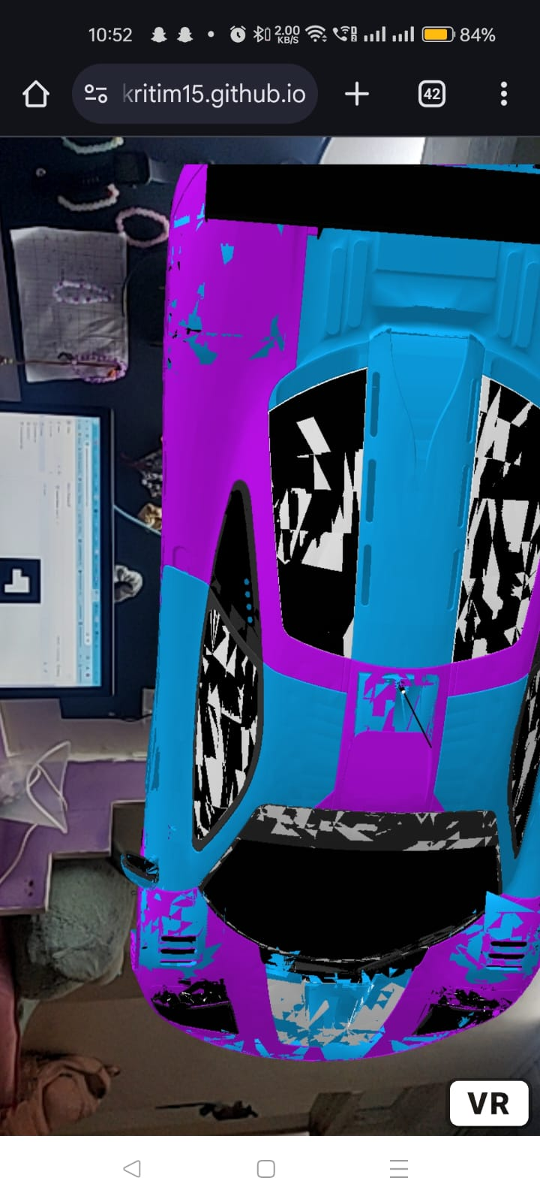

**Conclusion and discussion:**

**Learned AR.js for mclauren car ( 3d object).**

**Date: 11/10/24 Signature of faculty in-charge**